# **1.8 Inch SPI 128×160 TFT LCD Display Module With PCB for Arduino**

**SKU: 43400**

# **Sensor value display on TFT LCD using Arduino: Part I**

**Circuit diagram**  
**The figure shows that the circuit consists of only three components—POT (potentiometer), Arduino NANO board, and 1.8” TFT LCD.**

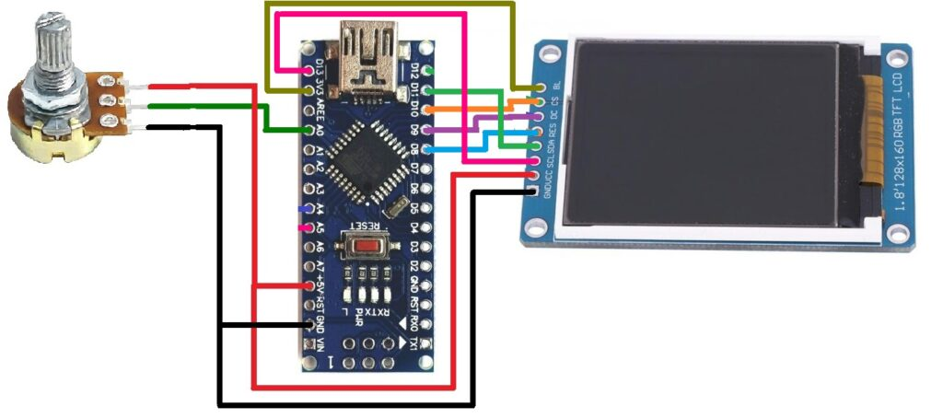

**Circuit connections:**  
**The potentiometer has three terminals. The two end terminals are connected with +5V and GND pins of the Arduino board, as shown. The middle-slider terminal is connected with analog input pin A0. Thus, rotating POT’s analog input voltage at pin A0 varies from 0 to 5V.**

The TFT LCD has a total of eight pins. It works on SPI protocol, so its pins are connected with the SPI pins of the Arduino board.

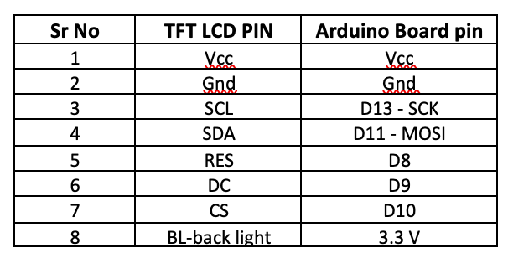

The Arduino 5V supply output directly powers the circuit. Since the Arduino is powered by the computer’s USB port (PC / laptop), there is no need for any external power supply.

**Circuit operation**  
**The POT is used to vary the analog voltage from 0 to 5V. This analog voltage is given to Arduino pin A0 as input. Arduino reads this analog voltage and converts it into a digital value between 0 to 1023. It is first converted into a string and then into an array of characters because TFT LCD can only display characters. The value is displayed as characters on TFT LCD. Arduino has a TFT library “TFT.h” that is used here along with other two libraries, “SPI.h” and “wire.h”.**

The Arduino TFT library has direct functions to display TEXT, graphics, and images in various colors on the TFT LCD. Since the TFT LCD works on SPI, we need an SPI library and wire library to communicate.Below is the software program in Arduino IDE for displaying POT value on TFT LCD.

**Program:**

#include <TFT.h>   
#include <SPI.h>  
#include <Wire.h>  
  
#define cs 10  
#define dc 9  
#define rst 8  
  
// create an instance of the library  
TFT TFTscreen = TFT(cs, dc, rst);  
String temp_value_str;  
char temp_str[5];  
float t;  
void setup()   
{  
 TFTscreen.begin();  
 TFTscreen.background(0, 0, 0);  
 TFTscreen.setTextSize(2);   
 TFTscreen.stroke(0,255,0);   
 TFTscreen.text("Temperature:", 5, 5);   
 TFTscreen.stroke(0,0,255);   
 TFTscreen.text("deg C", 5, 80);   
 TFTscreen.setTextSize(4);   
 Serial.begin(9600);   
}  
  
void loop()   
{  
 int red = random(0, 255);  
 int green = random (0, 255);  
 int blue = random (0, 255);  
 int pot_value = analogRead(A1);  
 t = 0.488*pot_value;  
 Serial.println(t);  
 temp_value_str = String(t);  
 temp_value_str.toCharArray(temp_str,5);   
 TFTscreen.stroke(red,green,blue);   
 TFTscreen.text(temp_str, 0, 40);   
 delay(1800);  
 TFTscreen.stroke(0,0,0);  
 TFTscreen.text(temp_str, 0, 40);   
 delay(200);   
}

Here is the snap of circuit arrangement with pot value displayed on the TFT LCD screen.

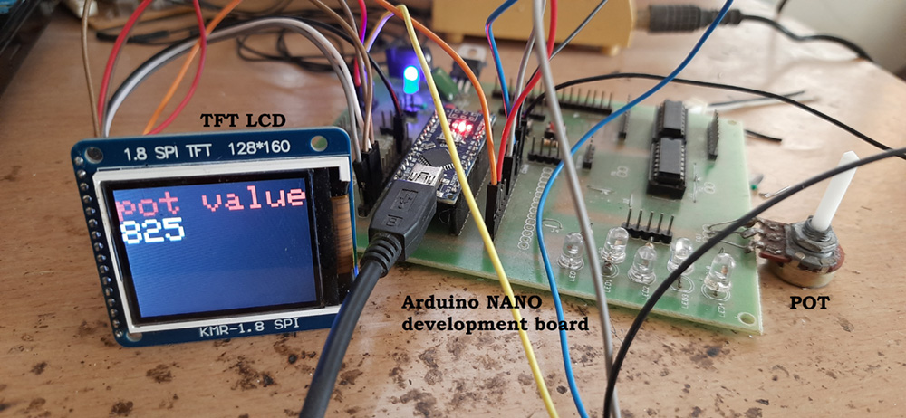

==========================================================================================================================================

**Now, we can connect any analog sensor with Arduino and display its data on TFT LCD.**

I will replace the POT with a widely-used and accurate temperature sensor, the LM35. It gives analog output voltage as ten mV/oC. Now, I will show you how to measure accurate room temperature and display it on TFT LCD. First, see the circuit diagram below.

**Circuit diagram:**

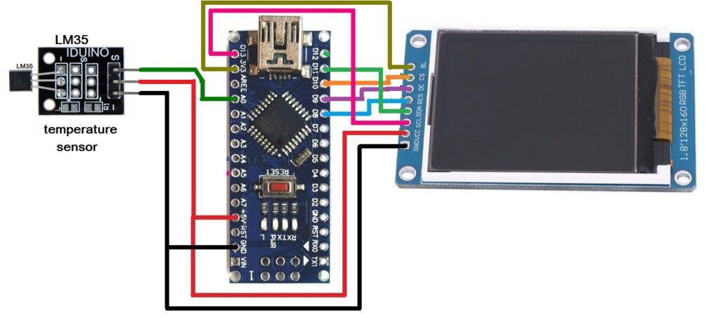

As shown in the circuit, I have replaced the LM35 sensor module in place of the POT.

The LM35 temperature sensor module also has three pins (terminals) (1) +V (2) G(-) and (3) S (signal). +V and G(-) are connected to +5V and GND of the Arduino board. S (signal) is the sensor’s analog output and is connected to analog input pin A0 of Arduino.

**Circuit operation:**  
**The LM35 sensor sense room temperature and gives analog voltage output from 0 to 1V. This analog voltage is given to Arduino pin A0 as input. Arduino reads this analog voltage and converts it into a digital value between 0 to 1023. This value is multiplied by a factor of 0.488* to get the exact room temperature value. This value is the float number. It is first converted into a string and further into an array of characters because TFT LCD can only display characters.**

We will now display this temperature reading on TFT. It is handled again similarly by TFT library functions. Here is the program code to display room temperature on TFT LCD.

#include <TFT.h>   
#include <SPI.h>  
#include <Wire.h>  
  
#define cs 10  
#define dc 9  
#define rst 8  
  
// create an instance of the library  
TFT TFTscreen = TFT(cs, dc, rst);  
String pot_value_str;  
char pt_str[4];  
void setup()   
{  
 TFTscreen.begin();  
 TFTscreen.background(0, 0, 0);  
 TFTscreen.setTextSize(3);   
 TFTscreen.stroke(255,0,255);   
 TFTscreen.text("POT Value", 0, 5);   
}  
  
void loop()   
 {  
 int red = random(0, 255);  
 int green = random (0, 255);  
 int blue = random (0, 255);  
 int pot_value = analogRead(A0);  
 pot_value_str = String(pot_value);  
 pot_value_str.toCharArray(pt_str,4);   
 TFTscreen.stroke(red,green,blue);   
 TFTscreen.text(pt_str, 0, 40);   
 delay(1800);  
 TFTscreen.stroke(0,0,0);  
 TFTscreen.text(pt_str, 0, 40);   
 delay(200);   
 }

Here is the snap of circuit arrangement with pot value displayed on the TFT LCD screen.



