 [Translated from Chinese (Simplified) to English - www.onlinedoctranslator.com](https://www.onlinedoctranslator.com/en/?utm_source=onlinedoctranslator&utm_medium=docx&utm_campaign=attribution)

**Wifi Relay Manual**

|  |  |
| --- | --- |
| file name | wifi relay manual.docx |
| version number | V1.0 |
| build date | 2016-2-17 |
| founder |  |
| revision history | 201Created on 6-2-17 |

Table of contents

**Chapter 1 Electrical Characteristics3**

1.1 Electrical Characteristics3

**Chapter 2 Precautions4**

2.1 Precautions4

**Chapter 3 Connection Instructions5**

3.1 Module description5

3.2 Definition of module terminals6

**Chapter 4 Support Command Description7**

4.1 Supported commands7

1. **electrical characteristics**
   1. **electrical characteristics**

Power supply voltage: DC 7-30V

Quiescent current: < 50Ma

Input IO maximum voltage: < 30V

Maximum voltage of relay output port: 250VAC/30VDC

Relay output port maximum current: 15A

1. **Precautions**

**2.1 Precautions**

1. The power supply voltage of the equipment must not exceed the maximum power supply voltage allowed by the equipment.

2. Do not reverse the polarity of the power supply, otherwise it will cause damage to the equipment.

3. Do not directly touch the electronic components of the device with your hands.

4. The IO input voltage must not exceed the maximum allowable input voltage.

5. The load connected to the relay output must not exceed the allowable value. When the device is powered on, do not touch the relay pins with your hands, because high voltage is dangerous.

1. **connection instructions**

**3.1 Module description**

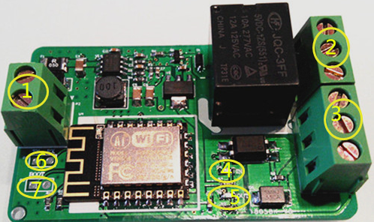

**Figure 1. Module diagram**

The description of the modules is as follows, see Figure 1 for the order of serial numbers:

1. Power input terminal.
2. Relay output terminal.
3. IO input terminal.
4. Input status indicator light, it lights up when the IO input is high level, blue light.
5. Relay output status indicator, lights up when the relay is on, red light.
6. TTL serial output.
7. Boot mode select jumper.

**3.2 Definition of module terminals**

The terminal definition is shown in the figure below:

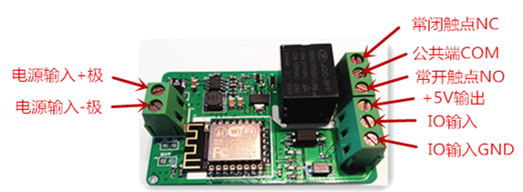

**Figure 2. Terminal definition**

1. **Support command description**

**4.1 Supported commands**

1. Turn on the relay

The server sends: open relay!

After the module turns on the relay successfully, it returns: relay on!

2. Turn off the relay

The server sends: close relay!

After the module successfully turns on the relay, it returns: relay off!

3. Get the status of the relay

The server sends: get relay state!

After the module turns on the relay successfully, it returns: relay on! or relay off!

4. Get IO status

The server sends: get io state!

After the module turns on the relay successfully, it returns: input io is: 1! or input io is: 0!

5. Get MAC

The server sends: get MAC!

After the module successfully opens the relay, it returns: device MAC.

**"Finish"**