#### High power DC-DC adjustable boost voltage

#### stabilized power module

#### NA466

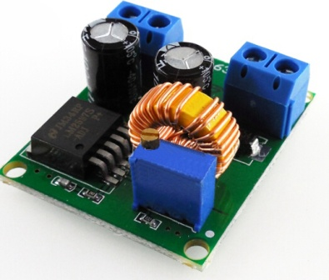

Product parameters:

|  |  |
| --- | --- |
| product name: | DC-DC adjustable boost module |
| Input voltage: | 3V-35V |
| The output voltage: | 4V-40V adjustable |
| efficiency: | 94%(MAX) |
| product weight: | 16.7g |
| Operating temperature: | -40℃-+85℃ |
| load capacity: | Maximum 80W |

Wiring method: No soldering required for terminal blocks, IN is input, 0UT is output

Note: The smaller the input and output voltage difference, the greater the load capacity and the higher the efficiency.

**Dimensional drawing:** L37MM*W32MM*H15MM

