BLE Bluetooth module and Windows 10 computer connection tutorial
Applicable models and PC conditions
1, The PC needs to bring its own Bluetooth, or use the external Bluetooth adapter, and the PC is WIN10 system.
2, Applicable to HC-02 Bluetooth 20 + 4.0BLE module, HC-08 Bluetooth 4.0BLE module, HC-42 Bluetooth 5.0BLE module
3, The module must be a slave, support the baud rate of the module itself.

Operation Procedure
1, The use of USB to TTL will HC-08 Bluetooth module connected to the computer, and open the serial port assistant.
2, Search in Microsoft Store (windows store) to download and install "BC BLE TOOL" software, or directly open the following link to download and install "BC BLE TOOL" software.
https://apps.microsoft.com/detail/9NH4G5R5FG77?hl=en-us&gl=US
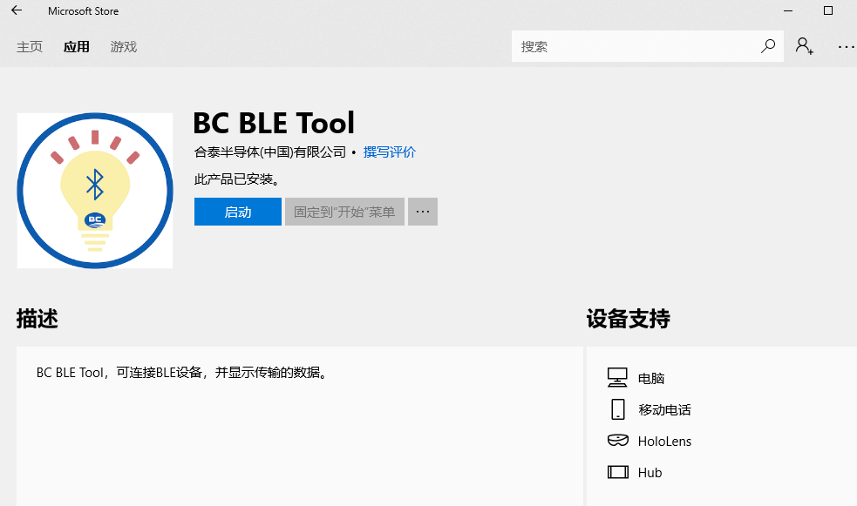
3, Open the BC BLE TOOL software, click Search, and connect the HC-08 Bluetooth module.
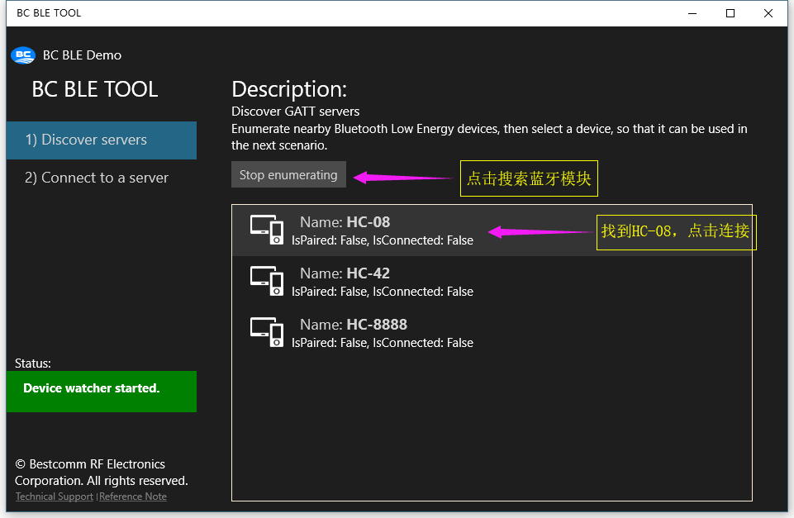

4, Select Connect to a server, click connect, connect to HC-08. no need to pair password, module indicator light from flashing to long light.
5, Select 65504, and then select 65505 ,you can enter the data sending and receiving interface.
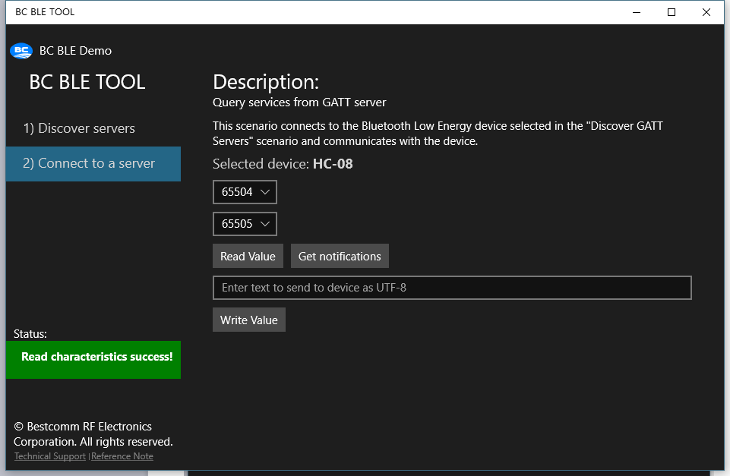
6, Enter any data, click Write Value, the serial port assistant can receive the written data.
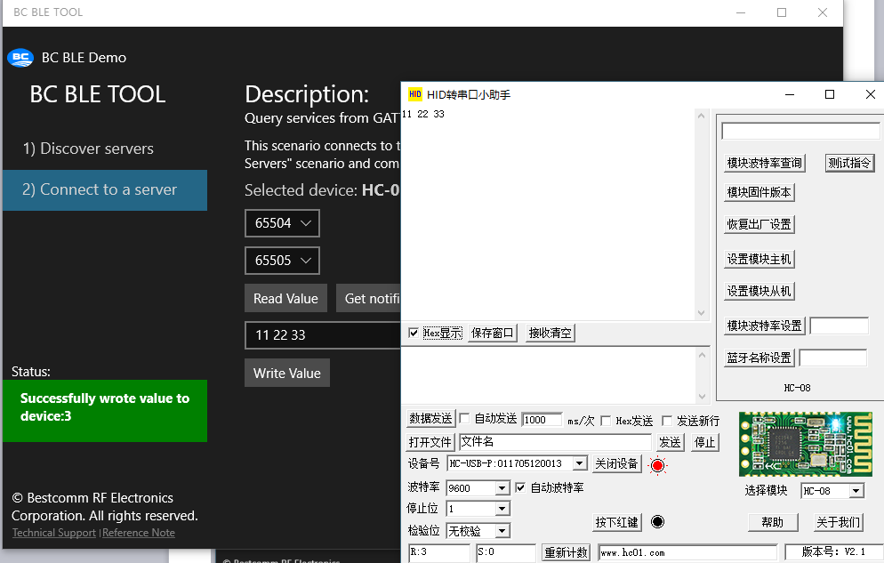

7, The same, click on the software interface of the Get notifications, you can receive data from the serial port assistant to send!
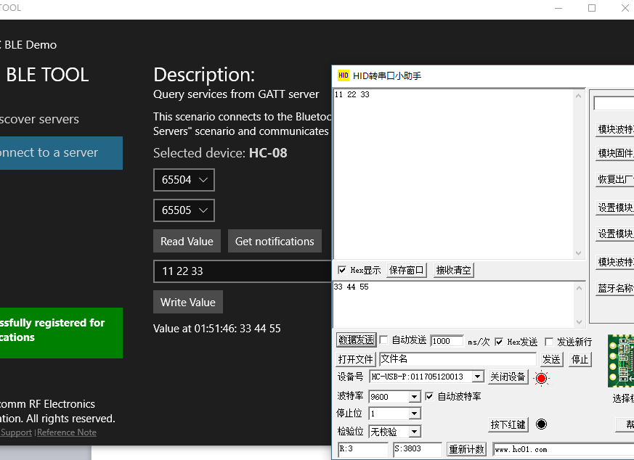
Attention
1, "BC BLE TOOL" software running on a PC, due to different computers, different systems, there may be flashback phenomenon, restart the software.
2, send and receive data, please select the HEX format to display and send, because the software only supports hexadecimal data format.
3, this tutorial only as a demonstration of Bluetooth BLE module can be connected with the PC's own Bluetooth or peripheral Bluetooth adapter communication, no other role, and can not provide the relevant source code or programming guidance, please understand!
4, HC-08 and HC-42 use exactly the same method, HC-02 need to select the UUID for reading and writing respectively, as follows:
(1) Selecting the write data UUID
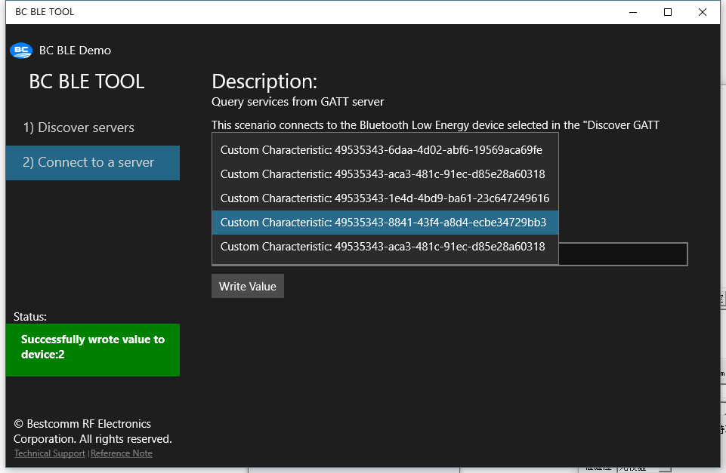
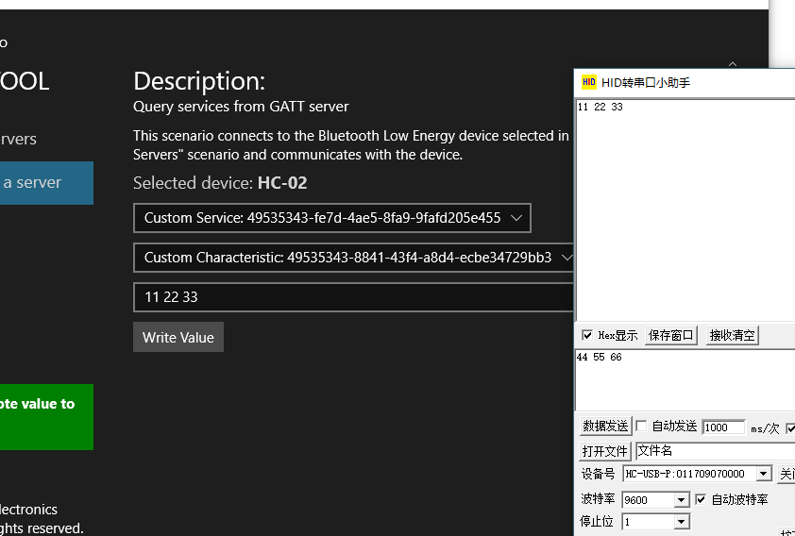
(2) Selecting the read data UUID
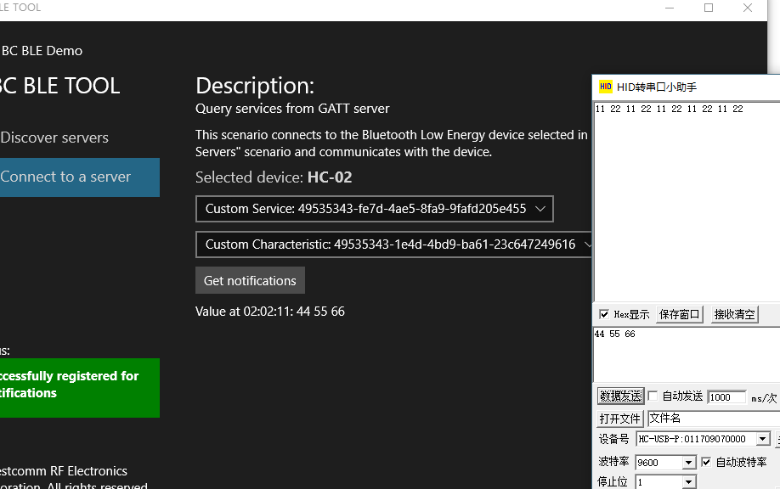
HC-02 Bluetooth 2.0+4.0 BLE Module UUID Notes:
Proprietary Service UUID:49535343-FE7D-4AE5-8FA9-9FAFD205E455
TX UUID:49535343-1 E4D-4BD9-BA61-23C647249616
RX UUID:49535343-8841-43F4-A8D4-ECBE34729BB3

