#### electric putter

##### NC481

Instructions for use of putter:

1. The push rod cannot work continuously for a long time. The putting efficiency is 10%-20%, working continuously for 2 minutes and resting for more than 18 minutes.

2. The push rod has a built-in limit switch. It stops automatically from start to finish (extends to the end and retracts to the end). Any power failure in the middle will stop the push rod and control the expansion and contraction by swapping the positive and negative poles (the positive and negative push rods extend, otherwise the push rod retracts). The two wires are not divided into positive and negative poles. If there is no response after connecting them, please swap the positive and negative poles.

3. The push rod stroke is not adjustable. It has been set at the factory and the internal limit switch is welded on. If you want to adjust and disassemble the push rod and re-weld the limit switch, it will be troublesome and is not recommended.

4. Under normal use, the faster the push rod, the smaller the thrust. After the push rod speed is selected, the push rod speed can only be adjusted by adjusting the voltage. At this time, the voltage is reduced, the speed is reduced, and the thrust force is reduced at the same time; you can choose to use a speed regulator to adjust the speed, and the speed range is from zero to the factory speed of the push rod. During the speed adjustment process, the smaller the speed, the smaller the thrust.

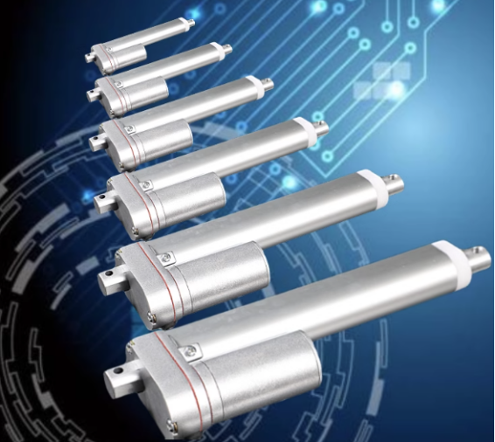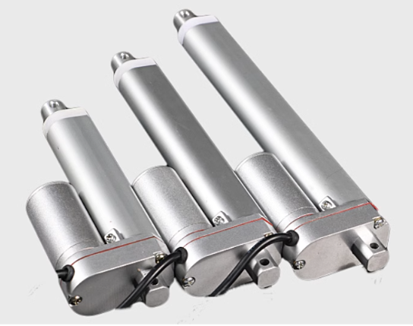

Product parameters:

|  |  |  |  |  |  |  |
| --- | --- | --- | --- | --- | --- | --- |
| model | no-load speed  (mm/s) | Thrust(N)  24V | Thrust(N)  12V | Current(A)  24V | Current(A)  12V | Self-locking force (N) |
| TGA | 5 | 900 | 900 | 0.6 | 1.1 | 900 |
| TGA | 7 | 1500 | 1200 | 0.6 | 1.1 | 1500 |
| TGA | 10 | 1200 | 900 | 0.6 | 1.1 | 1200 |
| TGA | 15 | 1000 | 700 | 0.6 | 1.1 | 1000 |
| TGA | 20 | 800 | 500 | 0.6 | 1.1 | 800 |
| TGA | 25 | 700 | 400 | 0.6 | 1.1 | 700 |
| TGA | 40 | 500 | 300 | 0.6 | 1.1 | 450 |
| TGA | 50 | 450 | 300 | 0.6 | 1.1 | 450 |

product details:

1. Interchangeable connectors

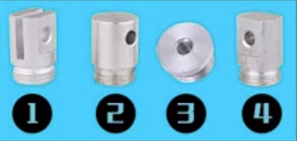

1. Excellent aluminum alloy material

Made of high-quality aluminum alloy material, with fine surface and various craftsmanship, high strength and no deformation

1. Zinc alloy gearbox

Made of zinc alloy in one piece, with higher hardness, better quality and longer life.

Product size chart:

Total retracted length: 105mm+stroke  
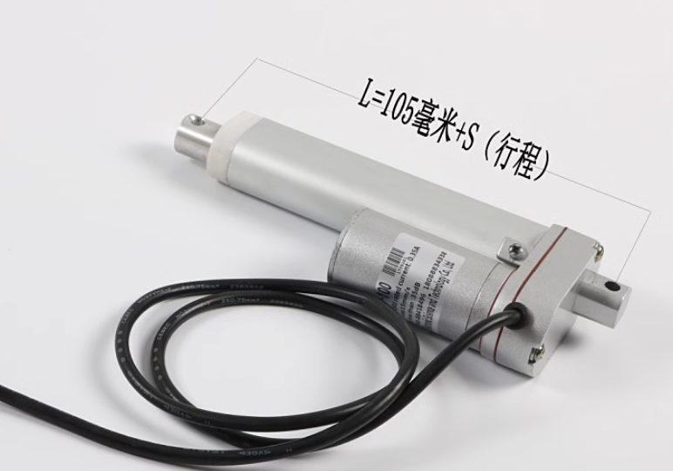

Total extension length: 105mm+stroke+stroke

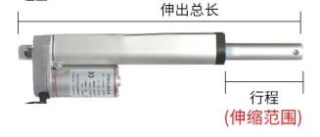

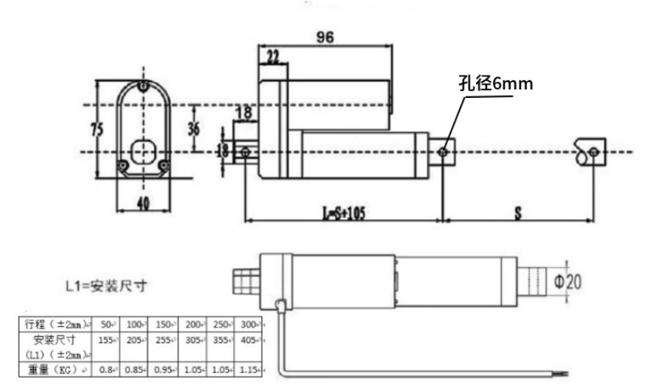

Applicable scene:

