1 Channel Relay Module

Product Parameters

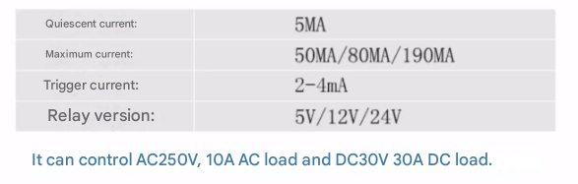

Product Description

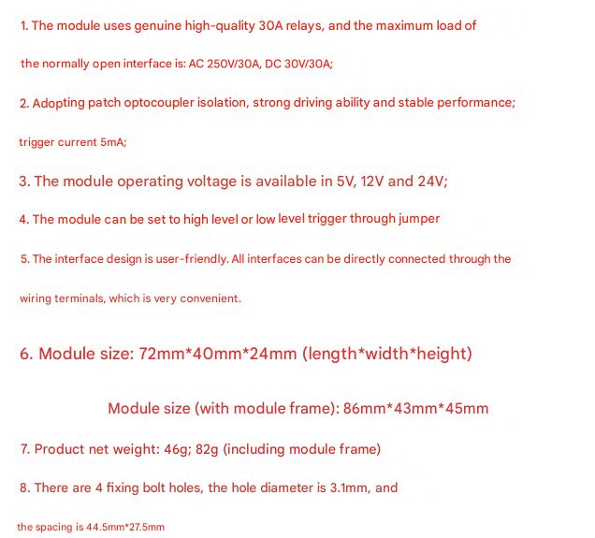

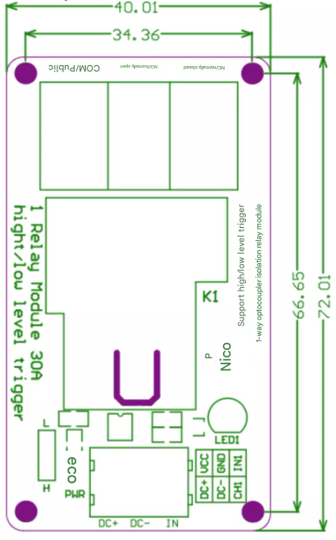

Module interface description:

1.DC+: module DC power supply positive pole

(trigger end voltage positive pole)

2.DC-: module DC power supply negative pole

(trigger end voltage negative pole)

3.IN: signal trigger end

(default trigger voltage is the same as power supply)

4. High/low level trigger mode selection, as shown in the figure, when the jumper is connected to the L end, the IN end is low level trigger, and when connected to the H end, it is high level trigger

5. Normally closed end (NC):Relay normally closed end

6. Common end (COM):Relay common end

7. Normally open end (NO):Relay normally open

