**ICL8038 12V to 15V Signal Generator Medium/Low Signal Frequency 10Hz-450KHz Triangular/Rectangular/Sine Wave Generator Module**

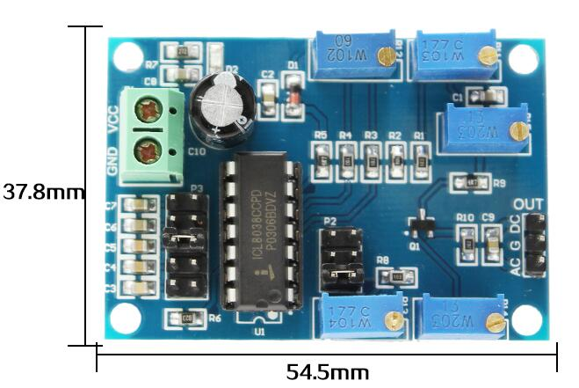

**Overview**

Elsevier ICL8038 module is designed for the commonly used frequency range, with 5 adjustable steps, it can generate low-distortion triangle wave, rectangle wave and sine wave pulse signals from 10Hz to 450KHz. Sine wave can be used for test signals, drive signals, carrier frequency signals, etc.; square wave can be used for switch signals, trigger signals, etc.; triangle wave is mainly used for scanning signals.

**Functional Characteristics**

1, Operating voltage: 12V～15V

2, Can output triangle wave, rectangular wave and sine wave.

3, Frequency range: 10HZ ~ 450kHz

4, Low distortion sine wave: 1%.

5, Duty cycle range: 2% ~ 98

6, Low temperature drift: 50ppm/°C

7, Triangle wave output linearity: 0.1%

8, Operating temperature: 0 ~ 70 ℃

**Hardware introduction and description**

Board size: 54.5*37.8mm



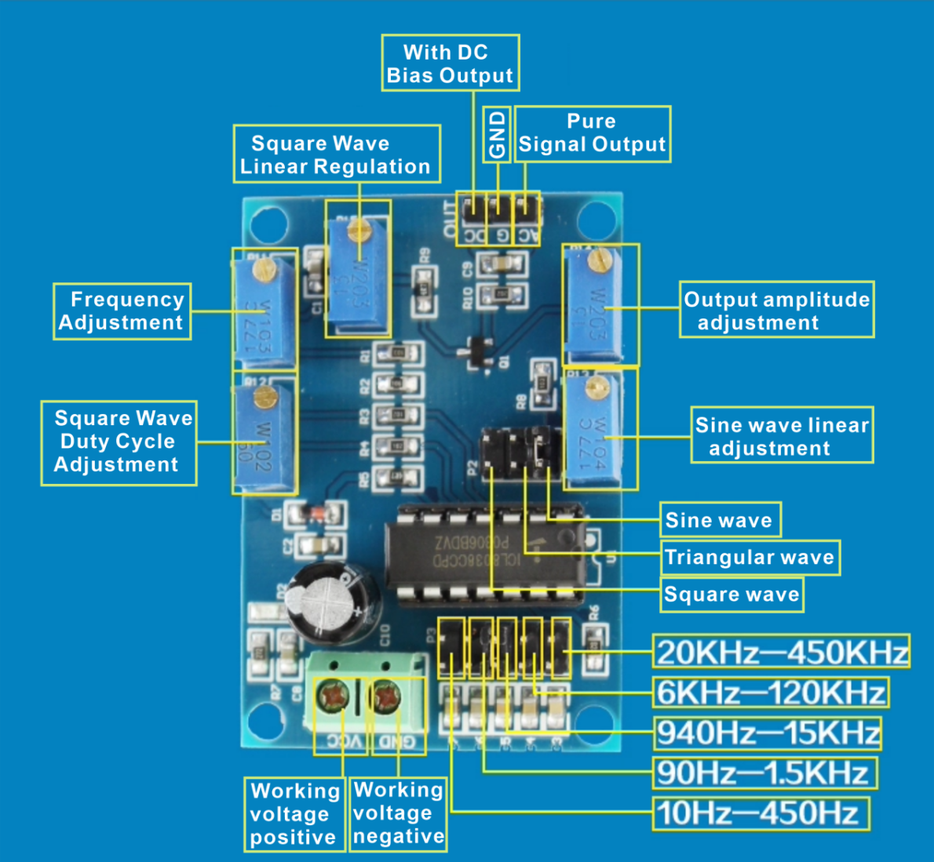

**Board function description:**

1, Interface description:

VCC: working voltage positive pole;

GND: negative pole of working voltage;

AC: with DC bias output;

G: ground;

DC: pure signal output;

2, P2 shorting cap to select different waveforms

P3 shorting cap to select different frequency range

10Hz-450Hz

90Hz-1.5KHz

940Hz-15KHz

6KHz-120KHz

20KHz-450KHz

Potentiometer R11: Frequency adjustment

R12: Square wave duty cycle adjustment

R13: Sine wave linear adjustment

R14: Output Amplitude Adjustment

R15: Square wave linear adjustment