 [Translated from Chinese (Simplified) to English - www.onlinedoctranslator.com](https://www.onlinedoctranslator.com/en/?utm_source=onlinedoctranslator&utm_medium=doc&utm_campaign=attribution)

Manual download link:

Flying Eagle Card (red) manual download link:https://pan.baidu.com/s/11linkZVPNTUxXueBx9Be-w Extraction code: 4sml

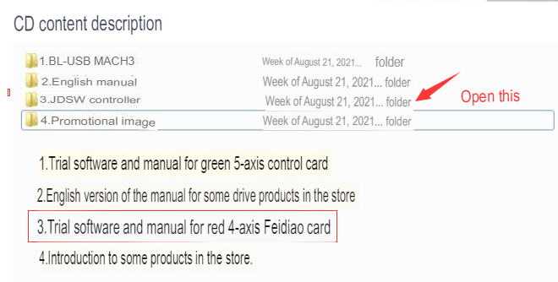

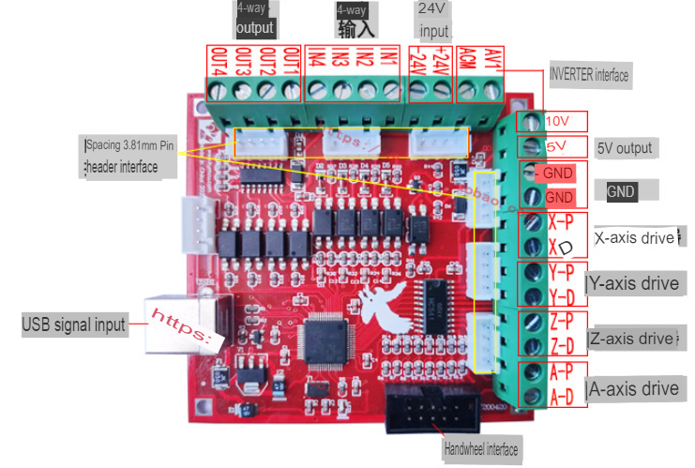

**Features:**

**l**Supports up to 4-axis linkage control. The 4th axis can be set as the slave axis  
**l**The output pulse is 100K, the minimum error interpolation algorithm is adopted, and the machining accuracy is high.  
**l**USB interface, suitable for any netbook, notebook, desktop with USB interface

**PC compatible computer such as computer and tablet, as long as MACH3 can run, the control card can be used.**

**l**Driver-free design, better compatible with various software and hardware environments (support WinXP and WIN7 systems)  
**l**Support automatic return to origin (return to zero)  
**l**The driven axis is automatically leveled during homing  
**l**Support automatic tool setting  
**l**Support emergency stop input  
**l**Support limit switch access  
**l**Support spindle control (PWM mode and relay mode)  
**l**Provides 4 digital signal inputs with optocoupler isolation  
**l**Provide up to 12 digital signal inputs, default 4  
**l**Provides 4 relay outputs with optocoupler isolation  
**l**Support handwheel interface  
**l**Anti-interference design, imported industrial grade components, high reliability  
**l**Provide screw terminal and 2.54MM spaced cable terminal