DC7V-12V Brushless Motor Driver Controller Board For Hard Drive Motor 3/4 Wire

AH054

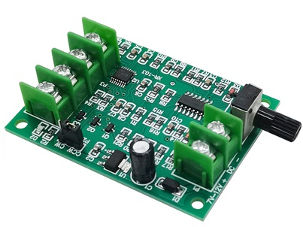

**Product Features**

This driver board can drive hard disk brushless motor, optical drive brushless motor and other miniature 3-wire or 4-wire no Hall brushless motor driver board has voltage reverse protection, overcurrent protection, short circuit protection, wiring is simple to use and very worry-free. Hard disk motor using voltage 7-12V can be turned, the higher the voltage the faster the speed can reach a maximum of about 10,000 rpm.

**Product Parameters**

Driving voltage: DC 7-12V

Working current: ≤1.2A

Speed control range: 0%-100

Phase control: Yes

Voltage reversal protection: Yes

Over-current protection: Yes

Short circuit protection: Yes

**dimension drawing**

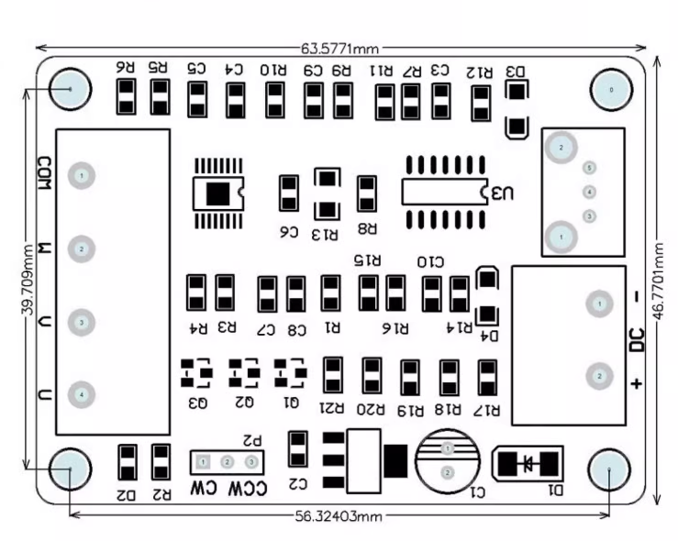

**Product Function Diagram**

